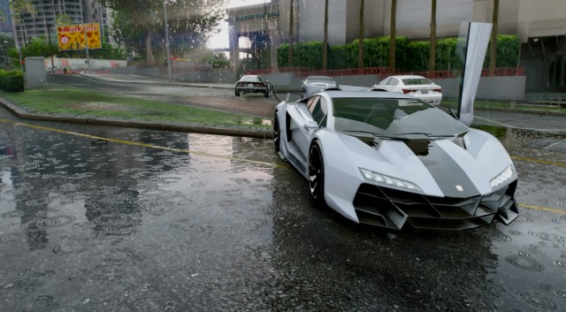Eric Ventor

Eventor

Part D

This screenshot is from GTA V and depicts a rainy day with a gorgeous sports car. Taking a few minutes to really grasp all the visual effects that are taking place left me amazed at just how gorgeous this game really is. To start, the car reflects what little sunlight there is on this rainy day. Then just looking over a little bit and noticing not only the puddle of water that has collected but the rain drops and reflection of the skyscrapers. Looking a bit further back we can see actual water droplets in the air and rays of sunlight shining through. I can’t imagine the complexity and just how daunting the actual code and design for this game really is. The game takes into consideration so many different elements including weather, space, time, surroundings, lighting and more. Not only is the objective to make the game visually appealing but to also remain as optimized as possible for gamers. Being able to not just create art but optimized art is truly a feat. The actual process of creating this games graphics definitely includes 10s of thousands of hours of labor if not more. The actual creation of this type of scenery still leaves me confused how they have accounted for every possible scenario. I believe the reflection is done by mapping the reflection and turning down the opacity. Overall the fact that I had yet to notice such astounding details in this game is for shame.

This image is just a moment of this gorgeous scenic atmosphere. Walking around completely alters the way the world is rendered. For example, if we were to take a few paces to the left quite a few things would occur such as the reflection moving seamlessly and stepping in the puddle would cause the water to splash. The most impressive to me is by far the reflection. There must be quite a bit of math and code to properly angle a reflection and then reflect it onto water. I believe that walking would cause updates to the texture itself in the case of the reflection. Because as you move the angle chases and the game updates what the water should be displaying. So it isn’t merely just changing pixel colors or shapes but an actual texture that is constantly being rendered.

Overall GTA is one of my favorite games and I’d say this screenshot does a pretty good job of depicting why. There is a lot going on in the background that I never really stopped to pay attention to and admire. I never noticed before this how water actually reflects its surroundings. Just to think that 10 years ago I was happy with Modern Warfare 2 graphics and technology has yet to cease improving. Who knows what new profound advancements will be made for our gaming pleasure in the next 10 years.